Assignment 1
Mohamed Shafiq Bin Roslan | 6098253
- Allow the user to enter whether he/she wants to use a CPU or GPU device. Based on the
user’s selection, search the system for all CPU or GPU devices. (Note that some systems
have multiple CPUs and GPUs).

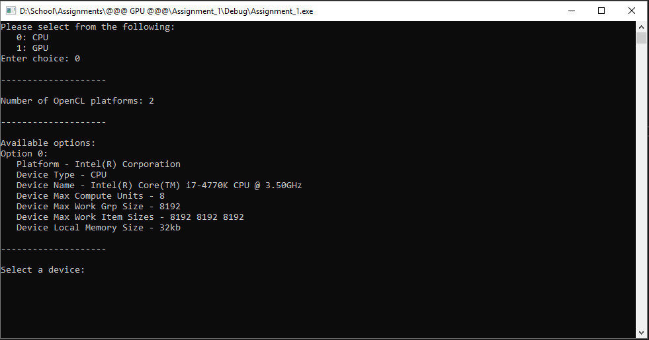

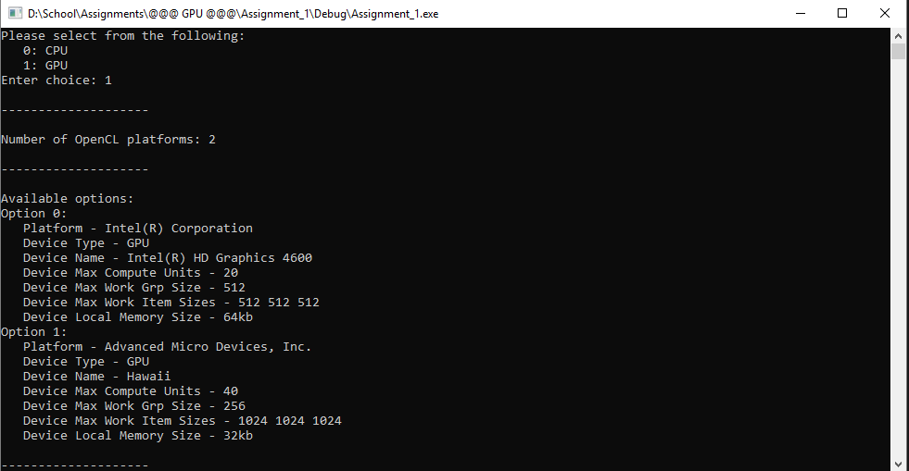

- Based on the user’s choice, display the following information for each CPU/GPU device
that is available on the system:
o Name of the platform(s) that support that device
o Device type – CPU or GPU
o Device name
o Number of compute units
o Maximum work group size
o Maximum work item sizes
o Local memory size

- Based on the devices available, allow the user to select one device. Create a context using
that device, and a command queue.

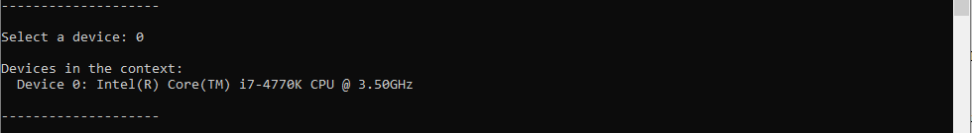





- Read the program source code from the provided “source.cl” file and build the program.
Display whether or not the program built successfully and display the program build log
(display the build log even if the program built successfully).

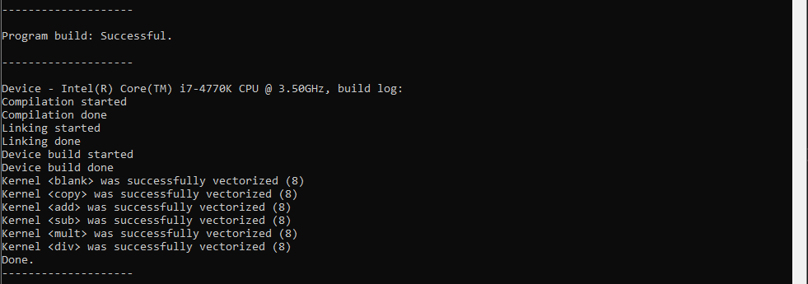

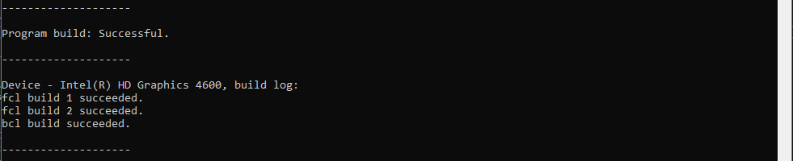

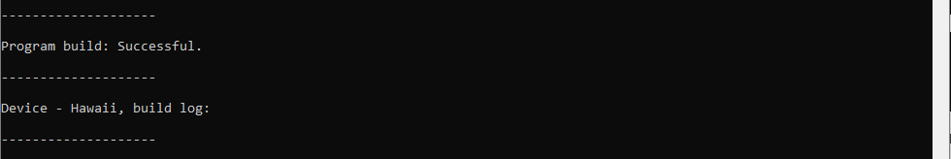
- Find and display the number of kernels in the program. Create kernels from the program and
display all the kernel function names.

